**New District 201C2 Project**

**Lions Club Member Vehicle**

**Number Plate Frames**

The managing club the Lions Club of Noarlunga Morphett Vale have for sale, promotional Lions Club Vehicle Number Plate Frames.

All profit generated from all sales will be forwarded to the Australian Lions Foundation to be used in the provision of grants to Lions Clubs for approved projects for the betterment of their communities.

The frames are suitable for use on standard size Australian vehicle number plates as seen below.

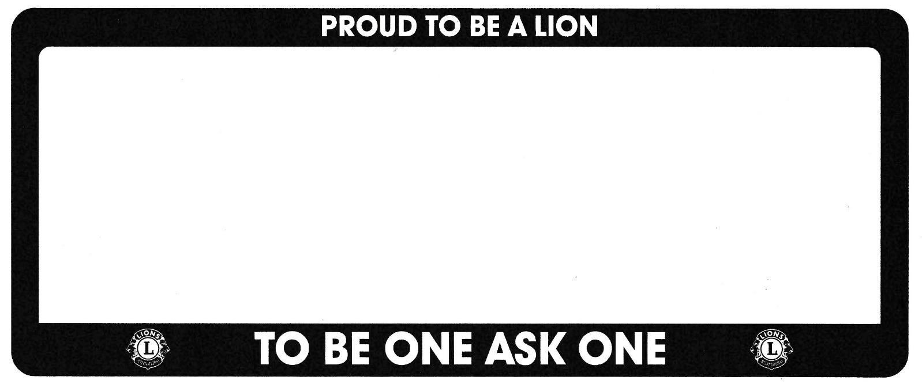

The cost is $15.00 per pair plus freight.

Therefore, should members in your club wish to obtain these frames it would be beneficial to order a quantity rather than singly.

A District 201C2 Project

Managed by the Lions Club of Noarlunga-Morphett Vale.

**

|  |  |
| --- | --- |
| Submitted by |  |
| Phone |  |
| Email |  |
| Address |  |
| City & Postcode |  |

|  |  |  |
| --- | --- | --- |
| Quantity | $15 per pair of frames | Amount |
|
|  |  |  |
|  |  |  |
|  |  |  |
|  |  |  |
|  | Total |  |

|  |  |
| --- | --- |
| Lions Club of Noarlunga Morphett Vale  Contact email [lionsnmv@gmail.com](mailto:lionsnmv@gmail.com)  Ph Bob Radford on 0418 823 760  or 0493 282 622 (club phone)  PO Box 101 Morphett Vale 5162  **NB Freight is charged in addition as may be required** | Bank account details  BSB 105136  Account no 521709340 |